**Exercise 2. Architect the Solution Architecture**

**Name: _________ Zou Xuan _______________ Date: _______10Feb2019_________**

# Architectural Decisions

|  |  |
| --- | --- |
| **Architectural Decision – One time historical data migration** | |
| **Decision ID** | **LD001** |
| **Issue** | **SHS will retrieve historical medical records for students from mainframe.** |
| **Architectural Decision** | Develop a one-time program to migrate all the historical records to new system database |
| **Assumptions** | 1. All the migration history should pass new system business validation  2. In case there’s invalid data, there will be rules to convert to valid data. |
| **Alternatives** | Develop an online endpoint for retrieving one student’s records each time |
| **Justification** | 1. Given mainframe holds over 10 million students’ profile and screening data, online endpoint to retrieve and filter data will be slow.  2. One-time data migration decouples the new system with mainframe, making the new system easier to maintain. |

|  |  |
| --- | --- |
| **Architectural Decision – Develop an embedded synchronization system in client side** | |
| **Decision ID** | **LD002** |
| **Issue** | **New system should be able to support both connected (via Internet) and disconnected (at childcares) mode** |
| **Architectural Decision** | Develop an embedded synchronization system, create a new thread in client side to run the synchronization system to auto scan client DB and send data to server |
| **Assumptions** | Client is opened and not able to connect to internet occasionally |
| **Alternatives** | Develop a windows service to scan client DB |
| **Justification** | 1. Embedded synchronization system will auto send data to server when it detects internet connected.  2. It is bind to client, making no other outside process can disable it. |

|  |  |
| --- | --- |
| **Architectural Decision – Develop desktop application + SQLite as client DB** | |
| **Decision ID** | **PD001** |
| **Issue** | **New system should be able to support both connected (via Internet) and disconnected (at childcares) mode** |
| **Architectural Decision** | Develop a desktop application with embedded database |
| **Assumptions** | N.A. |
| **Alternatives** | 1. H2 2. Derby 3. HSQLDB (HyperSQL Database) as client DB |
| **Justification** | SQLite is lightweight and file based, which makes it extremely portable.  SQLite is written in the C language and supports multiple languages and cross platform.  SQLite is so widely used that it is likely that has more library. |

|  |  |
| --- | --- |
| **Architectural Decision – Use MySQL as server database** | |
| **Decision ID** | **PD002** |
| **Issue** | **The SHS system will need a database to store historical data and new data** |
| **Architectural Decision** | Use MySQL database |
| **Assumptions** | N.A. |
| **Alternatives** | 1. Oracle database 2. Microsoft SQL database |
| **Justification** | 1. Given the data structure is fixed, relational database is a better option. 2. MySQL is open source and is available for free download and installation. |

1. **Logical Architecture Overview**

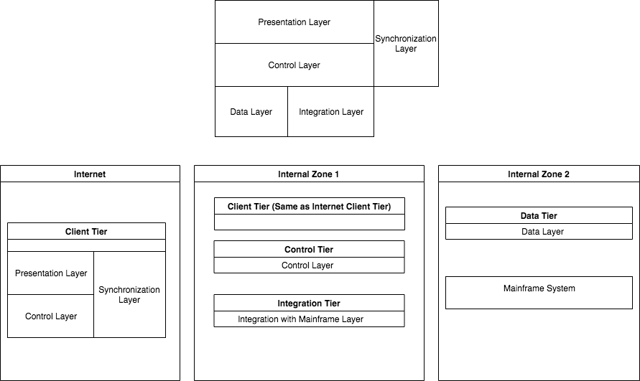

1. **Logical Functional Model (Outline)**

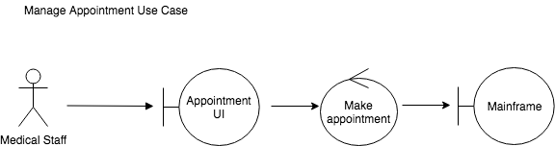

1. **Logical Deployment Model (Detailed)**

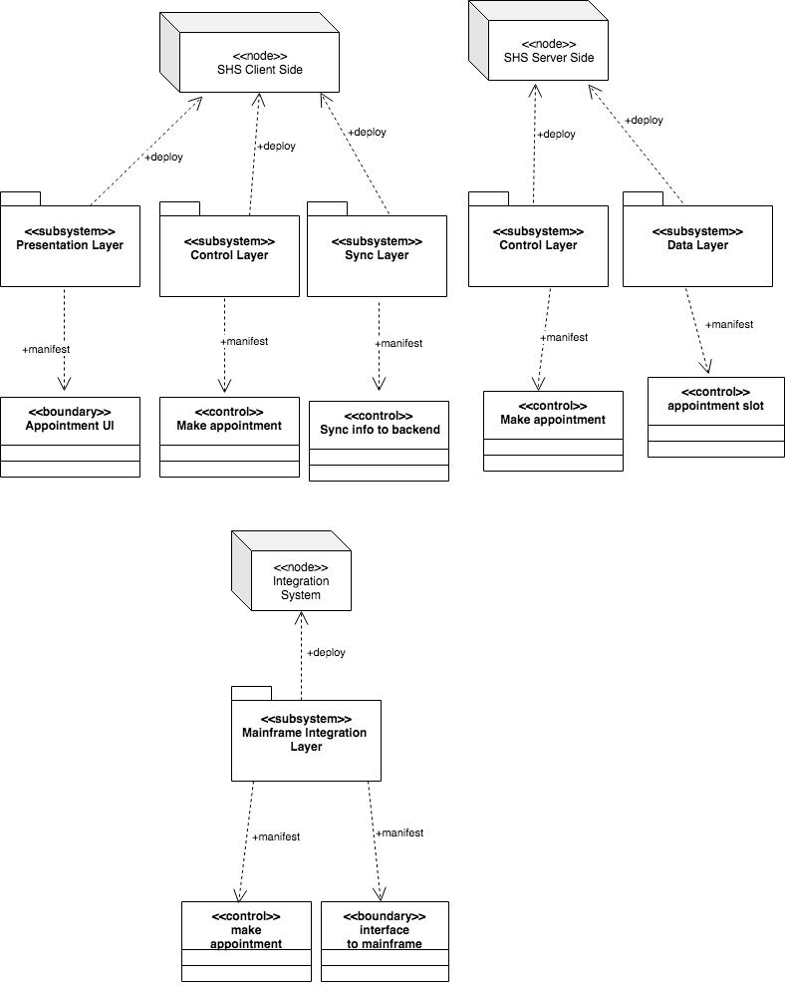

1. **Physical Architecture Overview**

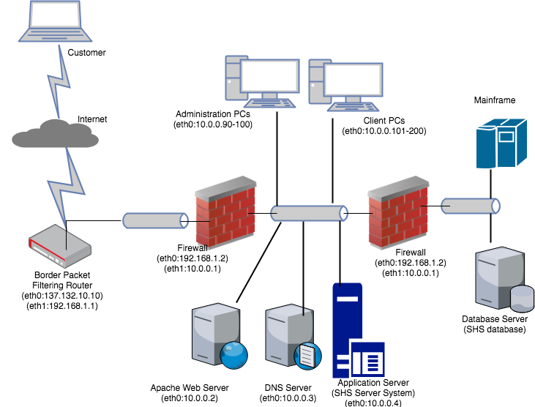

1. **Integration Endpoints**

|  |  |  |  |  |  |
| --- | --- | --- | --- | --- | --- |
| **Integration Endpoints** | | | | | |
| **Source** | **Destination** | **Protocol** | **Format** | **One/Two Way** | **Transformation Needed?** |
| **Mainframe** | **SHS** | **FTP** | **file** | **One Way** | **Yes** |
| **SHS Client** | **Application**  **Server** | **HTTP /**  **HTTPS** | **JSON** | **Two Way** | **Yes** |
| **Application Server** | **Mainframe** | **HTTP /**  **HTTPS** | **JSON** | **One Way** | **Yes** |
|  |  |  |  |  |  |
|  |  |  |  |  |  |
|  |  |  |  |  |  |
|  |  |  |  |  |  |
|  |  |  |  |  |  |

**Use this page if your answers cannot fit in the above boxes.**